**TASK 10**

1. Create a class called “Person” with attributes “name” and “age”. Also create a constructor and getter method for attributes.

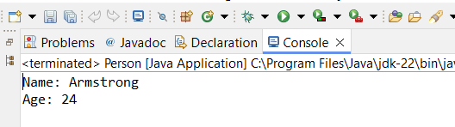

1. Salary of an employee

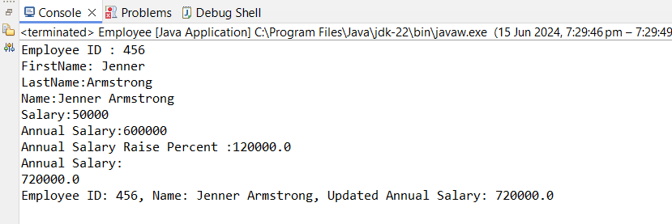

1. Circle and calculate circumference

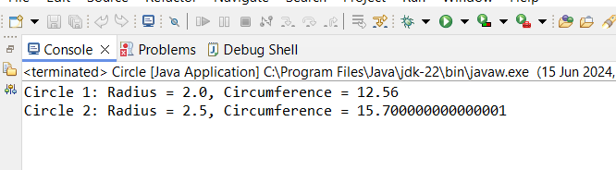

1. Bank account

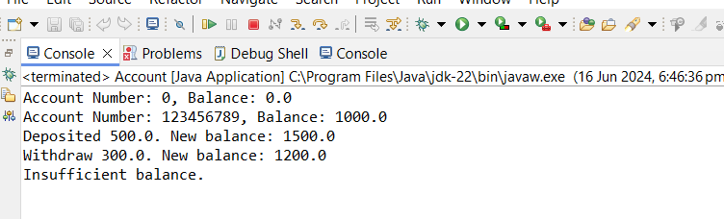

1. Basic tea preparation

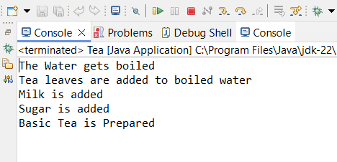

1. Black tea, green tea, herbal tea

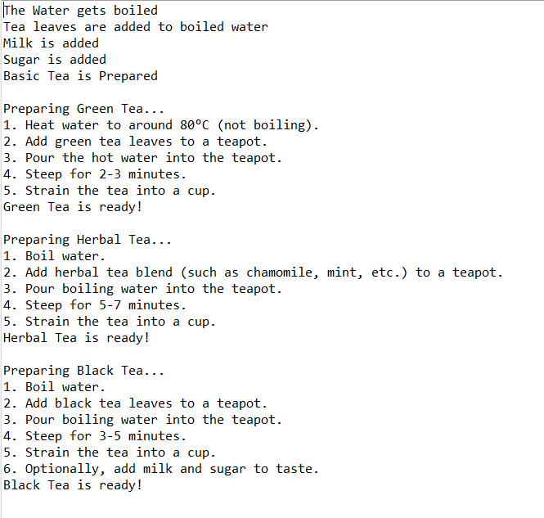

1. Implement polymorphism by creating array of tea objects include tea class and subclass

